CNSL Lab Assignment 2

Neeti Kurulkar

Demonstrate the different types of topologies and transmission media by using a packet tracer tool.

Topologies:

1. Bus Topology

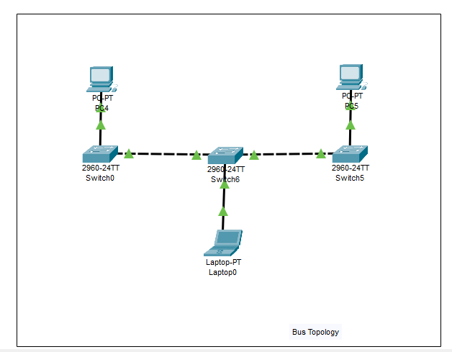

1. Star Topology

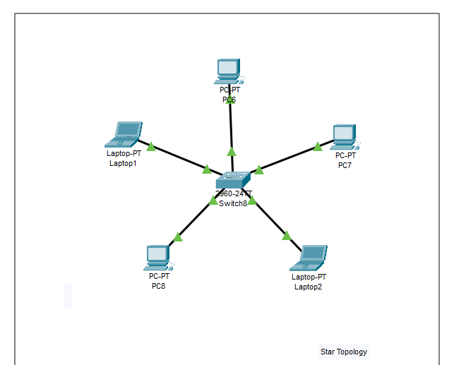

1. Ring Topology

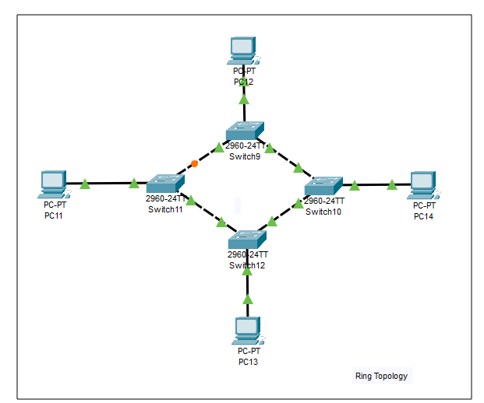

1. Mesh topology

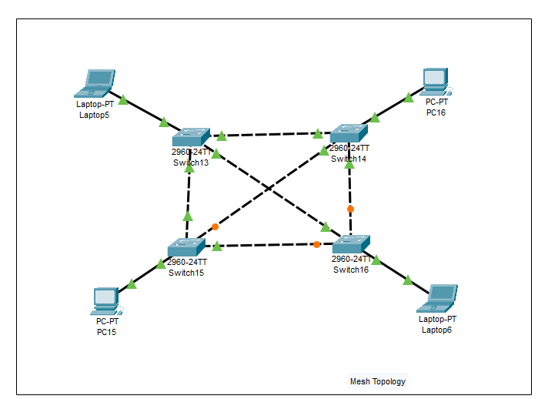

1. Hybrid Topology

